FOR IMMEDIATE RELEASE Contact: Melissa Ray Davis, Warren Wilson College
Phone: 828-771-3758
Email: melissa.davis@warren-wilson.edu

Warren Wilson College free tuition initiative expands local higher education access

North Carolina applications increase significantly over previous year

Asheville, NC – April 17, 2018 – Applications to Warren Wilson College from North Carolina residents have increased significantly this year, especially from the western part of the state. Warren Wilson’s new North Carolina Free Tuition Plan, which guarantees a tuition-free college education to every incoming North Carolina undergraduate student who is eligible for federal or state need-based aid, has piqued local interest.

“NC Free has definitely made me more interested in staying closer to home for college,” said Brevard High School senior Hazel Freeman from Brevard, NC. “[W]ith NC Free, I am able to enjoy my college experience without having to worry about a tremendous amount of student debt.” Freeman qualifies for free tuition at Warren Wilson College through NC Free.

Applications to Warren Wilson College from North Carolina residents are up 18 percent over last year as of the end of March, and application numbers increased more dramatically closer to Asheville. Western North Carolina applications are up 57 percent, and Buncombe County applications have increased 138 percent over the end of March last year. Warren Wilson College Accepted Students Day had record attendance this year, higher than any previous accepted student event in the college’s history.

“I am thrilled to see our application numbers this year confirm that the Warren Wilson College NC Free initiative has done exactly what we intended it to do – expand access to college education for students in this region, particularly access to the high quality integrated experience that Warren Wilson offers,” said Warren Wilson College President Lynn Morton. “Since its founding in 1894, this college has stood for educational access in this region. With NC Free, we are remaining true to our roots.”

“Both of my parents are teachers, so affording a private school was something everyone in my house was hesitant about. The determination and generosity of Warren Wilson has made me already feel like I am part of their community, and I can’t thank them enough for the NC Free program – it has made it a reality to attend my dream school,” said Clairissa Hitcho, a NC Free recipient from Fayetteville, NC.

“[NC Free] made it so I can finally go to a school close to home,” Asheville High School senior Zoe Sokolowski said. “I’ve wanted to attend Warren Wilson since I was in kindergarten! My schools were close to the college, and we would often take field trips and go on hikes near campus. I’ve always loved the ideas and philosophy of the college.”
-more-
Warren Wilson College has an innovative experiential curriculum that fully integrates on-campus work and off-campus community engagement. The college and its students are known for their strong commitment to environmental sustainability, diversity and social justice.

“When I received full tuition, it felt like everything was falling into place,” Hitcho said. “It has made it possible for me to be able to achieve my dreams, be close to my family and get to stay in the beautiful state of North Carolina.”

To inquire about admission to Warren Wilson College, please submit a Request for Information at https://www.warren-wilson.edu/request-information. Further information about NC Free is available at https://www.warren-wilson.edu/ncfree/.

Warren Wilson College is the only national liberal arts college that fully integrates on-campus work and off-campus community engagement into its curriculum. Visit https://www.warren-wilson.edu.


Warren Wilson College President Lynn M. Morton addresses accepted students and their families at Accepted Students Day in Asheville, NC on March 24, 2018. The event had record attendance this year, higher than any previous accepted student event in the college’s history. Photo: Reggie Tidwell

-more-
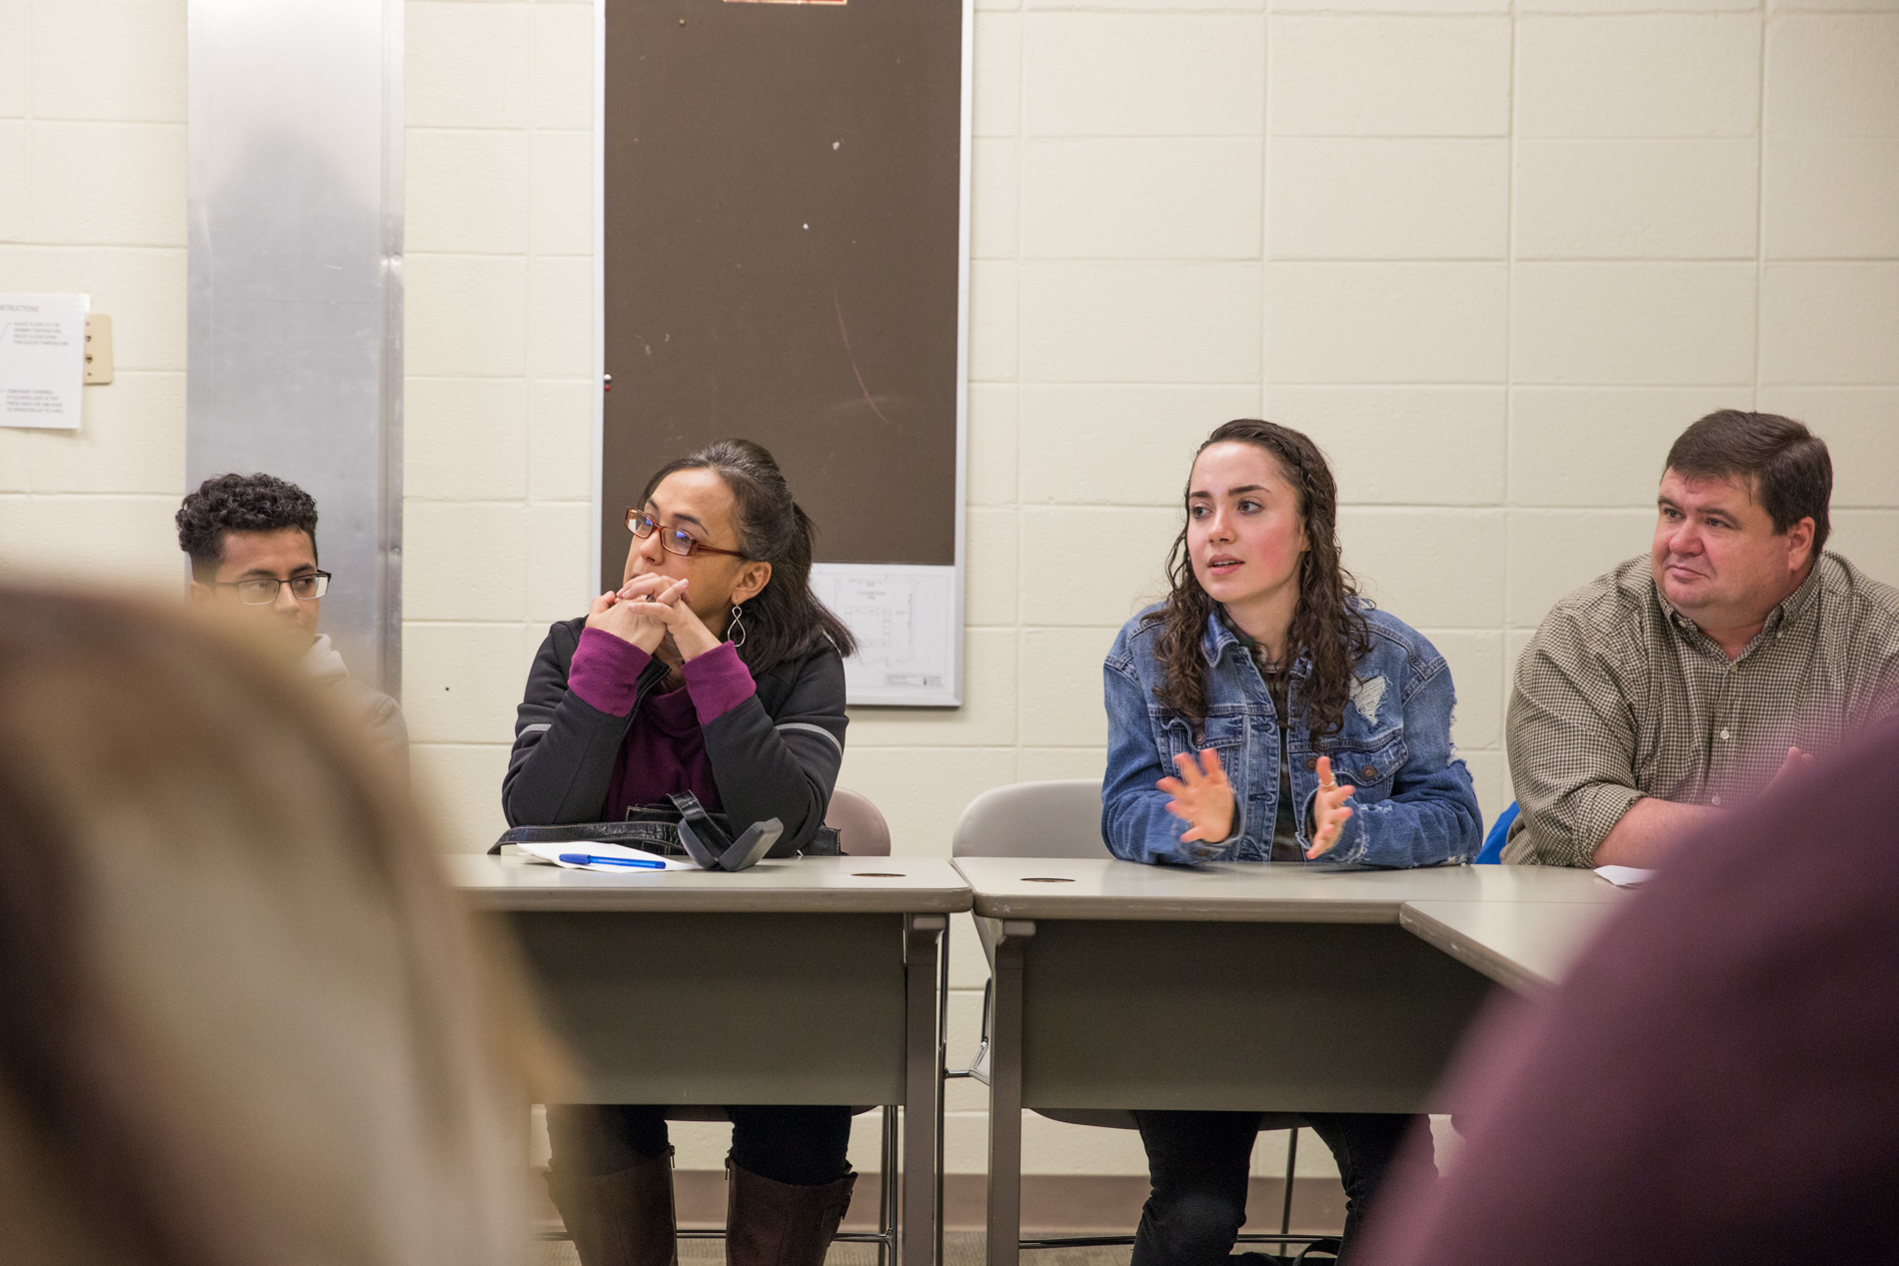
Accepted students and their families participate in classes during Accepted Students Day at Warren Wilson College in Asheville, NC on March 24, 2018. Photo: Reggie Tidwell

-more-


Accepted students and their families speak with students and faculty at the Biology and Environmental Studies plant sale during Accepted Students Day at Warren Wilson College in Asheville, NC on March 24, 2018. Photo: Reggie Tidwell

###

For more information, please call Melissa Ray Davis at 828-771-3758, or email melissa.davis@warren-wilson.edu.

